Experiment No : 8
Name: Shawn Louis
Roll No: 31
Batch: B

Problem Statement: | To implement 15 Puzzle Problem  Using Branch & Bound Strategy
Objective: | - To be able to implement a problem using branch & bound strategy
Expected Outcome: | - Ability to explain the problem statement  - Ability to build a puzzle using the specified strategy  - Ability to differentiate between brute force technique and branch and bound for the given problem.
Theory: | Problem Definition :  The 15 puzzle problem is invented by sam loyd in 1878.  - In this problem there are 15 tiles, which are numbered from 0 – 15.  - The objective of this problem is to transform the arrangement of tiles from initial arrangement to a goal arrangement.  - The initial and goal arrangement is shown by following figure.  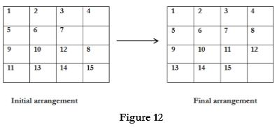  - There is always an empty slot in the initial arrangement.  - The legal moves are the moves in which the tiles adjacent to ES are moved to either left, right, up or down.  - Each move creates a new arrangement in a tile.  - These arrangements are called as states of the puzzle.  - The initial arrangement is called as initial state and goal arrangement is called as goal state.  - The state space tree for 15 puzzle is very large because there can be 16! Different arrangements.  - A partial state space tree can be shown in figure.  - In state space tree, the nodes are numbered as per the level.  - Each next move is generated based on empty slot positions.  - Edges are label according to the direction in which the empty space moves.  - The root node becomes the E – node.  - The child node 2, 3, 4 and 5 of this E – node get generated.  - Out of which node 4 becomes an E – node. For this node the live nodes 10, 11, 12 gets generated.  - Then the node 10 becomes the E – node for which the child nodes 22 and 23 gets generated.  - Finally we get a goal state at node 23.  - We can decide which node to become an E – node based on estimation formula.  Estimation formula:  C (x) = f (x) + G (x)  Where, f (x) is length of path from root to node x.  G (x) is number of non-blank tiles which are not in their goal position for node x.  C (x) denotes the lower bound cost of node x.  State Space Tree:  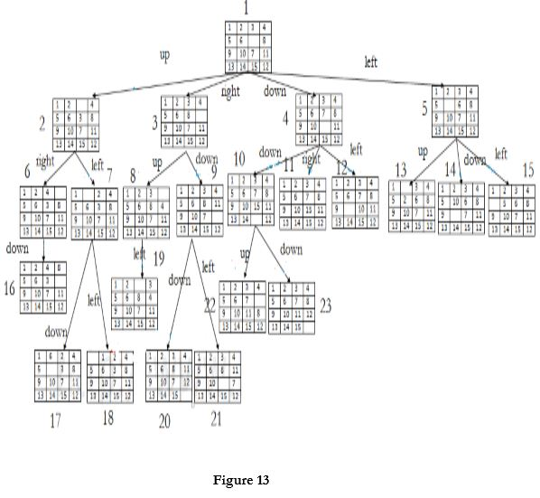
Algorithm: | We assume that moving one tile in any direction will have 1 unit cost. Keeping that in mind, we define a cost function for the 15-puzzle algorithm as below:  c(x) = f(x) + h(x) where  f(x) is the length of the path from root to x  (the number of moves so far) and  h(x) is the number of non-blank tiles not in  their goal position (the number of mis-  -placed tiles). There are at least h(x)  moves to transform state x to a goal state
Program Code: | #include<stdio.h>  #include<conio.h>  int m = 0, n = 4;  int cal(int temp[10][10],int t[10][10])  {  int i,j,m=0;  for(i=0;i < n;i++)  for(j=0;j < n;j++)  {  if(temp[i][j]!=t[i][j])  m++;  }  return m;  }  int check(int a[10][10],int t[10][10])  {  int i,j,f=1;  for(i=0;i < n;i++)  for(j=0;j < n;j++)  if(a[i][j]!=t[i][j])  f=0;  return f;  }  void main()  {  int p,i,j,n=4,a[10][10],t[10][10],temp[10][10],r[10][10];  int m=0,x=0,y=0,d=1000,dmin=0,l=0;  clrscr();  printf("\nEnter the matrix to be solved, space with zero :\n");  for(i=0;i < n;i++)  for(j=0;j < n;j++)  scanf("%d", &a[i][j]);  printf("\nEnter the target matrix, space with zero :\n");  for(i=0;i < n;i++)  for(j=0;j < n;j++)  scanf("%d", &t[i][j]);  printf("\nEntered Matrix is :\n");  for(i=0;i < n;i++)  {  for(j=0;j < n;j++)  printf("%d\t",a[i][j]);  printf("\n");  }  printf("\nTarget Matrix is :\n");  for(i=0;i < n;i++)  {  for(j=0;j < n;j++)  printf("%d\t",t[i][j]);  printf("\n");  }  while(!(check(a,t)))  {  l++;  d=1000;  for(i=0;i < n;i++)  for(j=0;j < n;j++)  {  if(a[i][j]==0)  {  x=i;  y=j;  }  }  //To move upwards  for(i=0;i < n;i++)  for(j=0;j < n;j++)  temp[i][j]=a[i][j];  if(x!=0)  {  p=temp[x][y];  temp[x][y]=temp[x-1][y];  temp[x-1][y]=p;  }  m=cal(temp,t);  dmin=l+m;  if(dmin < d)  {  d=dmin;  for(i=0;i < n;i++)  for(j=0;j < n;j++)  r[i][j]=temp[i][j];  }  //To move downwards  for(i=0;i < n;i++)  for(j=0;j < n;j++)  temp[i][j]=a[i][j];  if(x!=n-1)  {  p=temp[x][y];  temp[x][y]=temp[x+1][y];  temp[x+1][y]=p;  }  m=cal(temp,t);  dmin=l+m;  if(dmin < d)  {  d=dmin;  for(i=0;i < n;i++)  for(j=0;j < n;j++)  r[i][j]=temp[i][j];  }  //To move right side  for(i=0;i < n;i++)  for(j=0;j < n;j++)  temp[i][j]=a[i][j];  if(y!=n-1)  {  p=temp[x][y];  temp[x][y]=temp[x][y+1];  temp[x][y+1]=p;  }  m=cal(temp,t);  dmin=l+m;  if(dmin < d)  {  d=dmin;  for(i=0;i < n;i++)  for(j=0;j < n;j++)  r[i][j]=temp[i][j];  }  //To move left  for(i=0;i < n;i++)  for(j=0;j < n;j++)  temp[i][j]=a[i][j];  if(y!=0)  {  p=temp[x][y];  temp[x][y]=temp[x][y-1];  temp[x][y-1]=p;  }  m=cal(temp,t);  dmin=l+m;  if(dmin < d)  {  d=dmin;  for(i=0;i < n;i++)  for(j=0;j < n;j++)  r[i][j]=temp[i][j];  }  printf("\nCalculated Intermediate Matrix Value :\n");  for(i=0;i < n;i++)  {  for(j=0;j < n;j++)  printf("%d\t",r[i][j]);  printf("\n");  }  for(i=0;i < n;i++)  for(j=0;j < n;j++)  {  a[i][j]=r[i][j];  temp[i][j]=0;  }  printf("Minimum cost : %d\n",d);  }  getch();  }
Output Snapshot: | 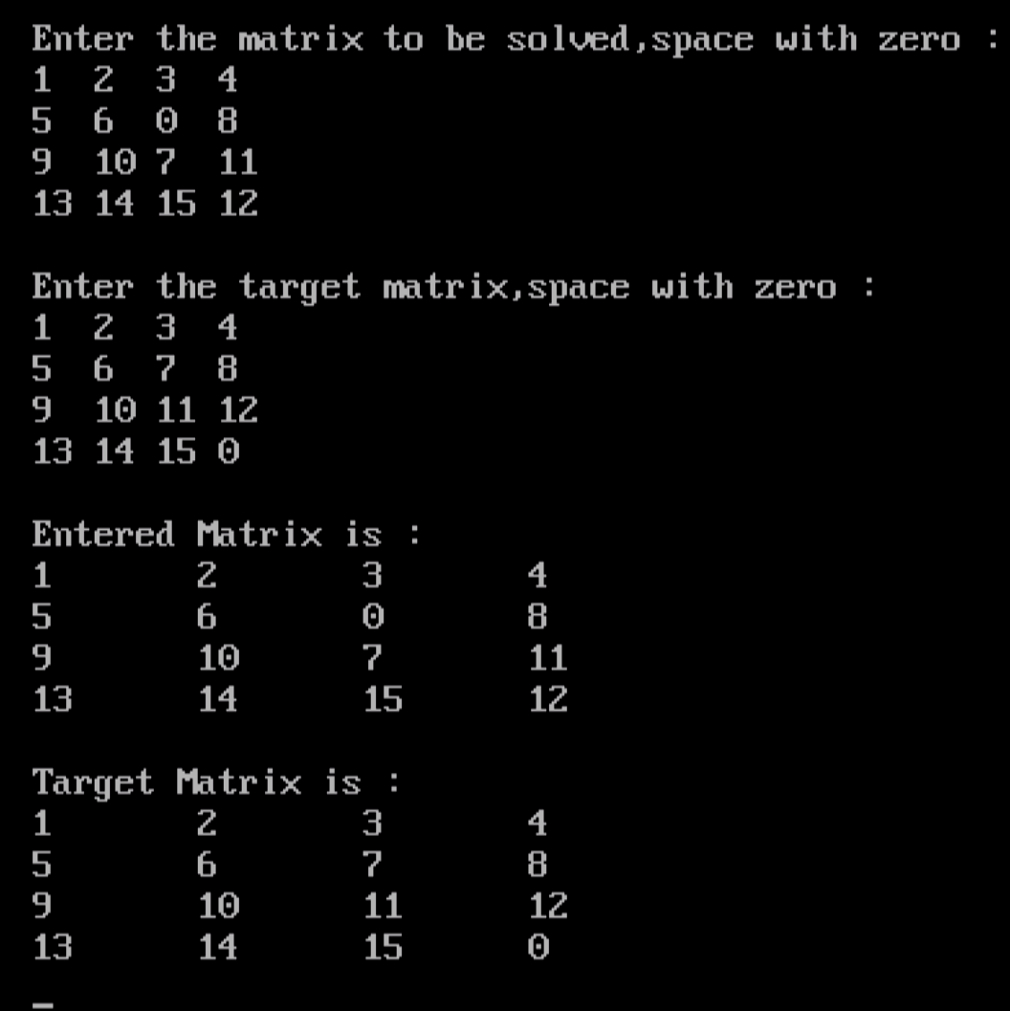  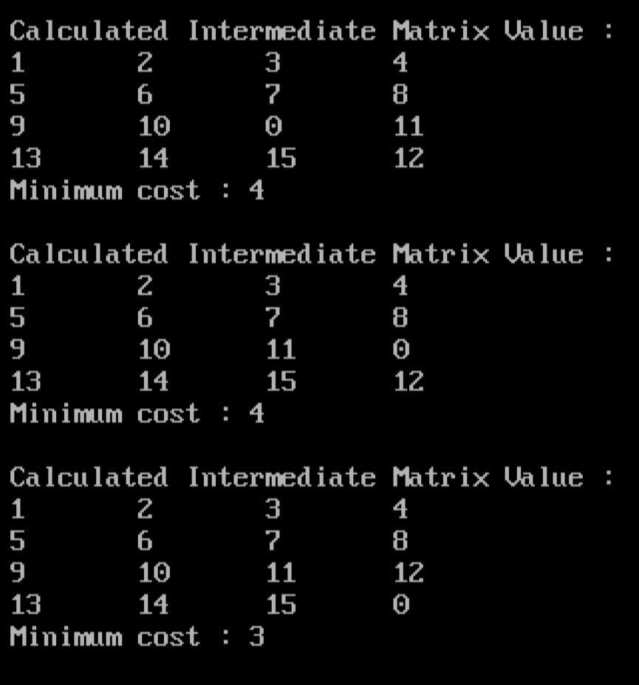
Application | The numbers in the rows, columns and both main diagonals all add up to 30.  Such an arrangement is called a Magic Square. There are 7040 different magic squares, but only 3520 of them can be solved with the blank in the lower right corner - as shown at the top of the page. The one shown above is the only one which is solvable within 35 moves and there are no magic squares which are solvable with fewer moves.
Outcome: | Successfully solved 15 puzzle problem using branch and bound strategy in C.

